भारतमौसमविज्ञानविभाग |  | India Meteorological Department
Wednesday,18th June 2025 (28 Jyeshtha 1947 Saka)
Summary of observations recorded at 0830 hours IST: Southwest Monsoon has further advanced over some more parts of North Arabian Sea, remaining parts of Gujarat, some parts of Rajasthan, some more parts of Madhya Pradesh, some parts of East Uttar Pradesh, remaining parts of Chhattisgarh and Jharkhand, and some more parts of Bihar. The Northern Limit of Monsoon passes through 25.0°N/60°E, 25.0°N/65°E, 25.5°N/70°E, Barmer, Jodhpur, Jaipur, Gwalior, Khajuraho, Sonbhadra, Gaya, and 30.5°N/82.5°E. Conditions are favourable for further advance of Southwest monsoon over remaining parts of North Arabian Sea, some more parts of Rajasthan, remaining parts of Madhya Pradesh, some more parts of Uttar Pradesh and remaining parts of Bihar, some parts of Uttarakhand, Himachal Pradesh, Jammu-Kashmir-Ladakh-Gilgit-Baltistan-Muzaffarabad during next 2-3 days. The Low-Pressure Area over southwest Bangladesh and adjoining Gangetic West Bengal moved west-northwestwards and became Well Marked Low Pressure Area over Gangetic West Bengal & neighbourhood at 1730 hrs IST of yesterday. It persisted over the same region at 0830 hrs IST of today, the 18th June 2025. The associated upper air cyclonic circulation extending upto 7.6 km above m. s. l. tilting southwards with height also persisted. It is likely to move slowly northwestwards across Jharkhand during next 24 hours. The Low-Pressure Area over Gujarat & neighbourhood lay over north gujarat region & neighbourhood at 1730 hrs IST of yesterday. It lay over southeast Rajasthan & neighbourhood at 0530 hrs IST of today. It then lay over central parts of Rajasthan at 0830 hrs IST of today, the 18th June 2025. The associated upper air cyclonic circulation extended upto 5.8 km above m. s. l. tilting southwards with height. A trough ran from Punjab to north Gujarat region across the cyclonic circulation over central parts of Rajasthan between 3.1 & 5.8 km above m. s. l. The Western Disturbance lay as cyclonic circulation over Punjab & neighbourhood between 3.1 and 4.6 km above m. s. l. However, the trough aloft in middle tropospheric westerlies with its axis at 5.8 km above m. s. l. roughly along Long. 72°E to the north of Lat. 30°N persisted. An upper air cyclonic circulation lay over central parts of Uttar Pradesh & neighbourhood between 3.1 & 5.8 km above m. s. l. The trough from the cyclonic circulation over southeast Rajasthan & neighbourhood to Jharkhand has become less marked. The upper air cyclonic circulation over northeast Assam & neighbourhood became less marked.
Day temperatures were markedly above normal (> 5.1°C) at few places over Arunachal Pradesh; at isolated places over Jammu-Kashmir-Ladakh-Gilgit-Baltistan-Muzaffarabad. appreciably above normal (3.1°C to 5.0°C) at isolated places over Assam & Meghalaya, Odisha, west Uttar Pradesh and Tamil Nadu, Puducherry & Karaikal. above normal (1.6°C to 3.0°C) at few places over Bihar; at isolated places over Nagaland, Manipur, Mizoram & Tripura, Sub Himalayan West Bengal & Sikkim, west Madhya Pradesh, Konkan & Goa, Vidarbha and Chhattisgarh. near normal (-1.5°C to 1.5°C) at many places over Madhya Maharashtra, Marathwada, coastal Andhra Pradesh & Yanam and north interior Karnataka; at most places over east Uttar Pradesh, Uttarakhand, Telangana, Rayalaseema and Lakshadweep; at few places over Andaman & Nicobar Islands, west Rajasthan, east Madhya Pradesh, coastal Karnataka and Kerala & Mahe; at isolated places over Gangetic West Bengal and south interior Karnataka. Yesterday, the highest maximum temperature of 42.8°C was reported at Orai (Uttar pradesh).
The Southwest Monsoon has been vigorous over Jharkhand, Gujarat Region, Saurashtra & Kutch and active over Gangetic West Bengal. It has been subdued over Marathwada, coastal Andhra Pradesh and Telangana.
Total 328 Station reported rainfall today. Total rainfall is 382.7 cm. Total 315 Station reported rainfall today whose normals are available. Total rainfall is 353.8 cm with normal station total is 237.4 cm.
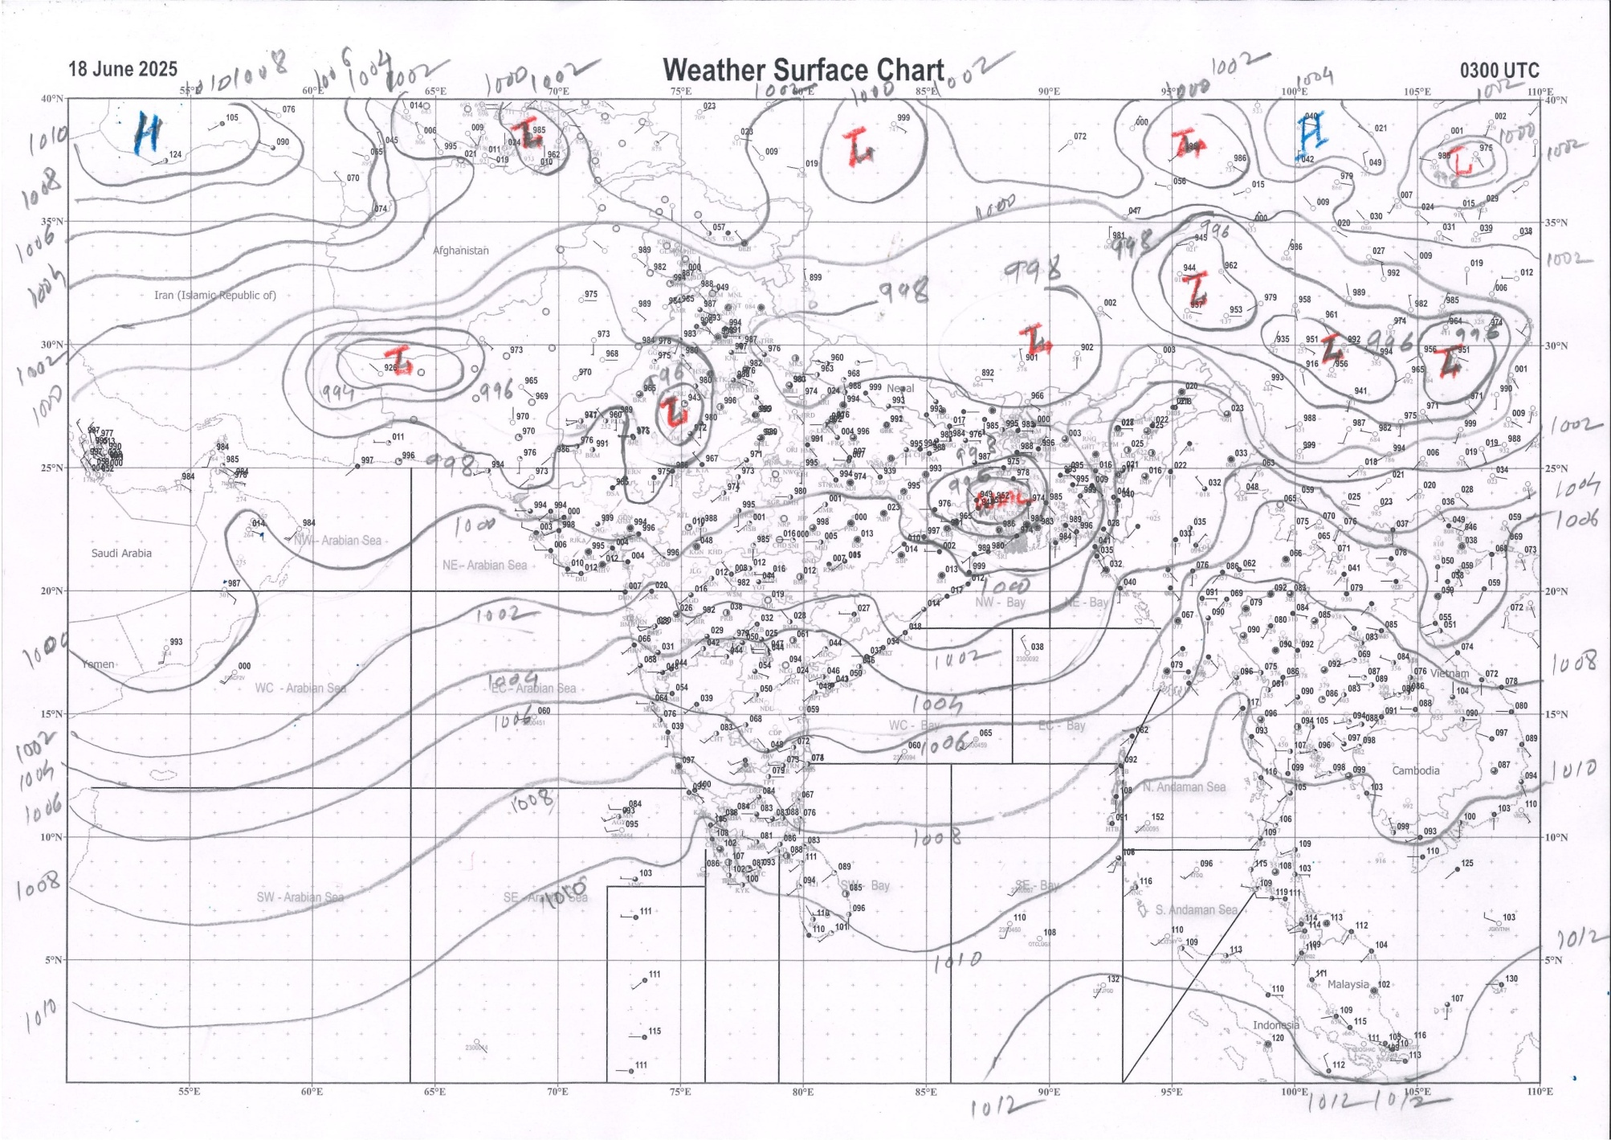 | 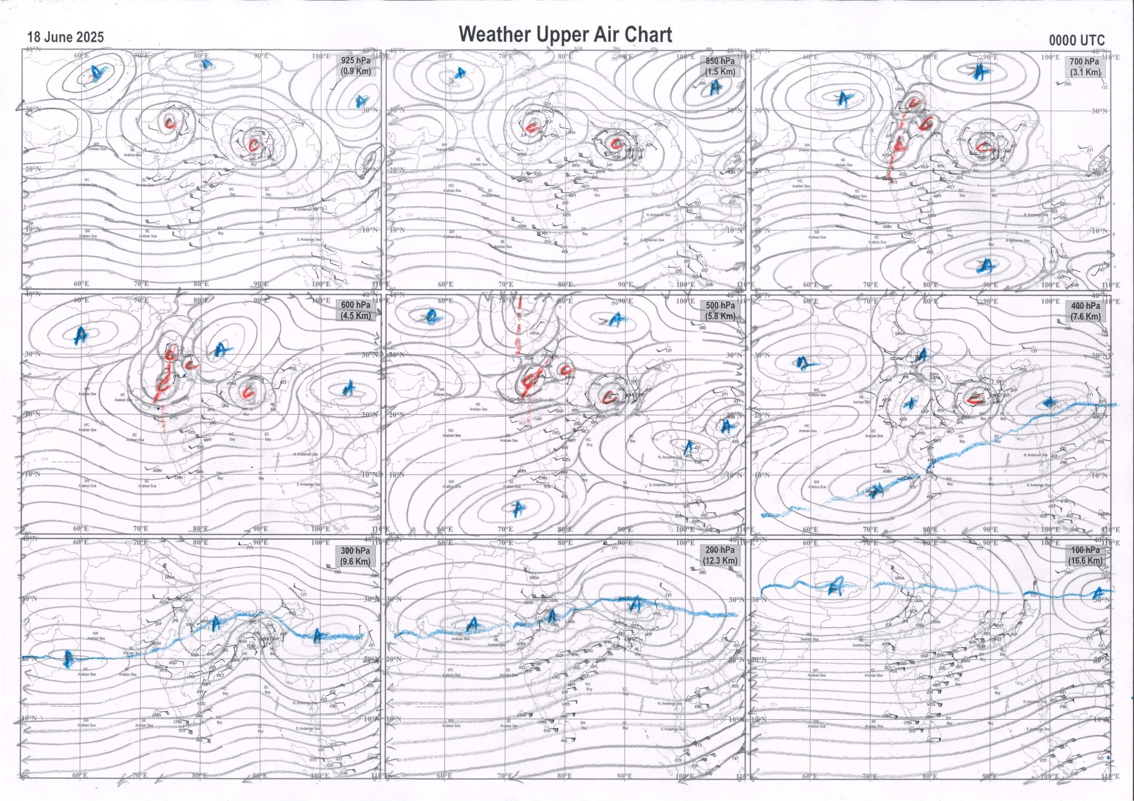
g.1. Analysed surface chart based on 03z observation | Fig.2. Analysed upper air chart based on 00z observation

Dr. S.D.Sanap
Scientist ‘D’
CR & S Office, Pune  Issued at 1245 hrs. IST |  | Weather Forecasting Division  CR&S, Pune

Indian regions | Realised rainfall (chief amount in cm during past 24 hrs):
East | most places: Gangetic West Bengal+++ and Jharkhand+++  many places: Arunachal Pradesh, Assam & Meghalaya+++, Nagaland-Manipur-Mizoram-Tripura, Sub-Himalayan West Bengal & Sikkim, Odisha+++ and Bihar+  Arki 15.6, Kuru 14.4, N.lakhimpur / Lilabari 13.6, Joda 13.0, Ranchi AP 12.8, Tiring 12.1, Chauldhowaghat & Asansol (CWC) 11.8 each, Asansol 11.2, Dobhi 10.5, Simula 9.3, Cherrapunji (rkm) 8.7, Nabinagar 7.4, Gaya AP 5.9, Shipgyar 5.8, Sabroom 4.7, Jung ARG & Keonjhargarh 4.6 each, Rongli 4.0, Tuting AWS 3.8, Sabroom AWS 3.7, Gangtok 2.8, Agartala AP 2.1, Ziro 1.4.
North | many places: west Uttar Pradesh+, Haryana+, Himachal Pradesh and east Rajasthan+  a few places: east Uttar Pradesh+ and Uttarakhand  isolated places: Punjab+, Jammu-Kashmir and Ladakh and west Rajasthan+  Bawal 10.3, Kaman 10.1, Nuh 9.4, Jhansi 9.0, Bahraich 8.7, Raniwada SR 8.4, Nabha 8.0, Sikrai 7.9, Aliganj 7.3, Baheri 7.0, Ghazipur 6.4, Kakardharighat 5.9, Dharchula, Churu & Pilani 5.3 each, Narnaul & Churu tehsil SR 5.2 each, Sundarnagar 5.0, Jaspur 4.9, Kotdwara 4.7, Khanna 3.8, Bhuntar AP 3.1, Gohar 2.5, Ludhiana 0.4, Leh AWS, Raj pura ARG & Rajouri ARG 0.3 each.
Central | a few places: east Madhya Pradesh+ and Chhattisgarh  isolated places: west Madhya Pradesh++ and Vidarbha  Narwar 15.7, Dindori-aws 11.1, Gaurihar 9.5, Kartala 4.9, Duldula 4.5, Ghatigaon 4.0, Datia-aws 2.9, Korchi 2.1, Arjuni morgaon 2.0, Pendra road 1.9, Nowgong 0.8.
Peninsula | most places: Gujarat Region+, Konkan & Goa+, coastal Karnataka+++ and Kerala+++  many places: Saurashtra & Kutch+++ and south interior Karnataka+  a few places: Madhya Maharashtra+  isolated places: Marathwada, coastal Andhra Pradesh, Telangana, Rayalaseema, Tamil Nadu+ and north interior Karnataka+  Sayla 15.6, Barvala 15.3, Taliparamba 12.0, Uppinangadi 11.7, Kandla airport 11.4, Kottigehara 9.9, Mudubidre 9.8, Bhagamandala 9.1, Chemberi AWS 8.5, Deodar 8.3, Radhanagari 8.1, Borsad 8.0, Shahuwadi, Avalanche & Londa 7.8 each, Mandangad & Chinnakalar 7.5 each, Mahabaleshwar 6.9, Poladpur 6.5, Kozhikode 6.2, Valparai PTO 5.7, Khanapur 4.3, Panambur 4.2, Balehonnur 3.6, Matheran 3.5, V.vidyanagar SR 3.1, Singanamala 1.6, Wankdi 1.4, Belagavi PTO 1.3, Eturnagaram & Cuddapah 0.9 each, Tada 0.7, Vasmat 0.5, Mentada 0.3, Garividi 0.2, Tondapur ARG & Kalingapatnam 0.1 each.
Islands | many places: Andaman & Nicobar and Lakshadweep  Port blair 2.2, Long island 1.6, Maya bandar 1.5, Amini 0.4, Agathi 0.3, Minicoy 0.2
Table 2. Forecast / warnings (distribution of rain / thundershowers) for 7 days (valid from time of origin upto 0830 hrs IST of next day)
Sr N. |  | Sub-division Name | Day 1 | Day 2 | Day 3 | Day 4 | Day 5 | Day 6 | Day 7 | Sr. No. | Sub-division Name | Day 1 | Day 2 | Day 3 | Day 4 | Day 5 | Day 6 | Day 7
 |  |  | 18 Jun | 19 Jun | 20 Jun | 21 Jun | 22 Jun | 23 Jun | 24 Jun |  |  | 18 Jun | 19 Jun | 20 Jun | 21 Jun | 22 Jun | 23 Jun | 24 Jun
 | 1 | Andaman Nicobar Islands | W  | W  | W | F | F | F | F | 19 | west Madhya Pradesh | F +  | F +  | F +  | F  | F ++  | F ++ | W ++ 
 | 2 | Arunachal Pradesh | W ++  | W ++  | W +  | F +  | F ++  | F ++ | F ++  | 20 | east Madhya Pradesh | F +  | F  | F ++  | W ++  | W ++  | W ++ | W ++ 
 | 3 | Assam-Meghalaya | F # | F ++  | F +  | W++ | W ++ | W ++ | W++ | 21 | Gujarat region | W ++  | F +  | F +  | W +  | W ++ | W++ | F ++
 | 4 | Nagaland-Manipur-Mizoram-Tripura | W++ | W+ | W+ | W++  | W++  | W ++ | W++  | 22 | Saurashtra and Kutch | W ++ | F+  | F  | F | W + | F + | F +
 | 5 | Sub Himalayan West Bengal/Sikkim | W+ | W+ | W | W | W + | W + | W + | 23 | Konkan and Goa | W ++  | W++ | W + | W + | W + | W + | W +
 | 6 | Gangetic West Bengal | W #  | W ++  | F | F | F | F + | W | 24 | Madhya Maharashtra | F ++  | S ++ | I + | I + | I + | I + | I +
 | 7 | Odisha | W # | W ++  | F + | F + | F + | S | F + | 25 | Marathwada | I  | I  | I  | I | I | I | I
 | 8 | Jharkhand | W# | W# | W ++  | W +  | F  | F | W  | 26 | Vidarbha | S  | F  | F  | S  | S  | S | S 
 | 9 | Bihar | F++ | F++ | F+ | F+ | S+ | S | S+ | 27 | Chhattisgarh | F ++  | F ++  | F ++ | F  | S  | S | S 
 | 10 | east Uttar Pradesh | F +  | W ++  | W ++ | W ++ | W +  | F +  | F +  | 28 | Coastal Andhra Pradesh and Yanam | I  + | I  + | I  + | I  + | I  + | I | I  +
 | 11 | west Uttar Pradesh | S + | F+ | W++ | W++ | W+ | F+ | F+ | 29 | Telangana | I  | I  | I  | I  | I  | I | I 
 | 12 | Uttarakhand | F + | F+ | F+ | F++ | W++ | F++ | F++ | 30 | Rayalaseema | I + | I + | I + | I + | I + | I | I +
 | 13 | Haryana,Chandigarh and Delhi | S  | I  | F + | W +  | W +  | S +  | F +  | 31 | Tamil Nadu, Puducherry and Karaikal | I +  + | I  + | I | I | I | I | I
 | 14 | Punjab | I  | I  | S  | F +  | W +  | F +  | S +  | 32 | Coastal Karnataka | W +  | W  | F | F | F | W + | W
 | 15 | Himachal Pradesh | S | S | F + | F + | F ++ | F ++ | F ++ | 33 | North interior Karnataka | I  | I | I | I | I | I | I
 | 16 | Jammu-Kashmir and Ladakh | I | I | I | F  | W+ | S  | s+ | 34 | South interior Karnataka | S  | S | I | I | I | I | I
 | 17 | west Rajasthan | S +  | I  | I  | I  | I  | I  | S  | 35 | Kerala and Mahe | W +  | W + | F | F | F + | F | F +
 | 18 | east Rajasthan | F++ | F++ | S+ | S+ | F++ | F++ | F++ | 36 | Lakshadweep | W  | W  | F | F | F | F | F
Legends: D = Dry I = Isolated S = Scattered F = Fairly widespread W = Widespread #= heavy to very heavy rain at a few places with extremely heavy rain at isolated places +++= heavy rain at a few places with very heavy rain at Isolated places ++= heavy to very heavy rainfall @=Isolated exceptionally heavy rainfall + = heavy rain ●/*= rain or snow ♦ = very light rain ≡=fog= thunderstorm with lightning =Squall / Gusty / gale / strong wind ­ =cold wave/cold day += heat wave/warm night/hot and humid weathe r=Duststorm =ground frost = Hail

Fig. 4: Districtwise warnings for five days for Maharashtra State
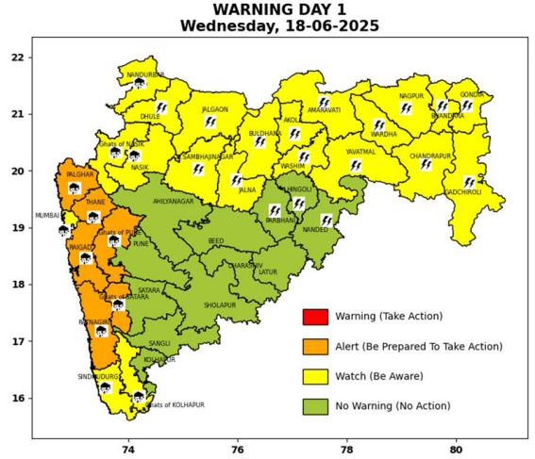 | 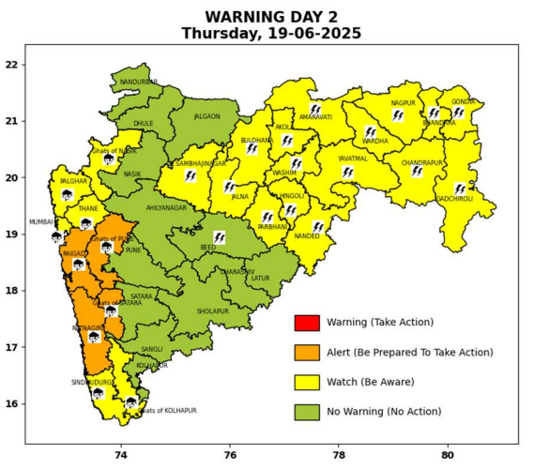 | 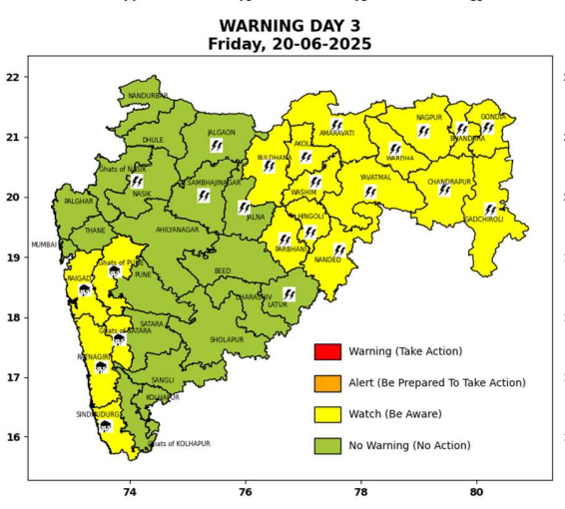 | 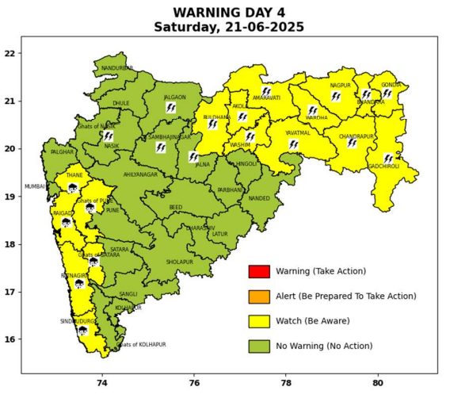 | 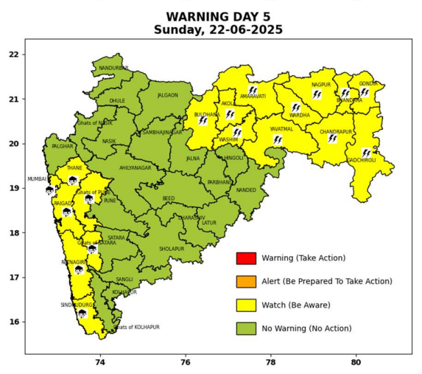

Pune, Lohegaon and Pashan observations at 0830 hrs. IST of Today
 | Temperature (°C) |  |  |  |  | Humidity (%) |  |  |  | Rainfall (mm)
 | Max.  past  24 hrs | Dep.  from  normal | Min.  past  24 hrs. | Dep.  from  normal | Dry  Bulb | At 0830 hrs. IST | Dep.  From  normal | At 1730  hrs. IST of y’day | Dep.  from  normal | Past  24 hrs. | Since  1st June | Dep.  from  normal
PNE | 29.8 | -1.1 | 23.1 | 0.2 | 25.8 | 81 | 2 | 79 | 9 | 6.0 | 178.9 | 86.9
PSN | 29.2 | - | 22.0 | - | 24.4 | 92 | - | 83 | - | 4.3 | 197.0 | -
LHG | 31.7 | -0.3 | 25.0 | 4.0 | 27.5 | 72 | -4 | 68 | 6 | 5.6 | 174.2 | 115.4

 |  |  |  |  |  |  | Local (Pune and neighbourhood) forecast
Max./Min. Temperature (°C) |  |  |  |  |  |  |  |  | Weather
Date | Pune | Pashan | Lohegaon | Chinchwad | Lavale | Magarpatta | NDA | Koregoan Park
18/06/25 | 29 / 23.1* | 28 / 22.0* | 30 / 25.0* | 28 / 23.5* | 27 / 22.7* | 30 / 24.6* | 29 / 23.5* | 29 / 24.3* | Generally cloudy sky. Light to moderate rain very likely
19/06/25 | 30 / 23 | 29 / 22 | 32 / 25 | 29 / 23 | 29 / 22 | 31 / 24 | 28 / 23 | 30 / 24 | Generally cloudy sky. Light to moderate rain very likely
20/06/25 | 31 / 23 | 30 / 22 | 33 / 25 | 30 / 23 | 30 / 22 | 32 / 24 | 29 / 23 | 31 / 24 | Generally cloudy sky. Light rain very likely.
21/06/25 | 32 / 22 | 31 / 21 | 33 / 24 | 31 / 22 | 31 / 21 | 33 / 23 | 30 / 22 | 32 / 23 | Generally cloudy sky. Light rain very likely.
22/06/25 | 32 / 22 | 31 / 21 | 33 / 24 | 31 / 22 | 31 / 21 | 33 / 23 | 30 / 22 | 32 / 23 | Generally cloudy sky. Light rain very likely.
23/06/25 | 32 / 23 | 31 / 22 | 33 / 24 | 31 / 23 | 31 / 22 | 33 / 23 | 30 / 23 | 32 / 23 | Generally cloudy sky. Light rain likely.
24/06/25 | 32 / 23 | 31 / 22 | 33 / 24 | 31 / 23 | 31 / 22 | 33 / 23 | 30 / 23 | 32 / 23 | Generally cloudy sky. Light rain likely.
Rainfall Distribution |  |  | Rainfall Categories | Rainfall (mm) |  | Cloud condition |  |  |  | Rainfall Intensity |  | Range
Widespread (W) | 76-100% |  | Very Light rain | Trace to 2.4 mm |  | Mainly clear sky |  | 1-2 oktas |  | Light Spell |  | 1 cm/hr
 |  |  | Light rain | 2.5 to 15.5 mm |  | Partly cloudy sky |  | 3-4 oktas |  | Moderate Spell |  | 1-2 cm/hr
Fairly Widespread (FW) | 51 – 75% |  | Moderate rain | 15.6 to 64.4 mm |  | Generally cloudy sky |  | 5-7 oktas |  | Intense Spell |  | 2-3 cm/hr
Scattered (S) | 26 – 50% |  | Heavy rain | 64.5 to 115.5 mm |  | Overcast |  | 8 oktas |  | Very Intense Spell |  | 3-5 cm/hr
isolated (I) | 1 – 25% |  | Very heavy rain | 115.6 to 204.4 mm |  |  |  |  |  | Extremely Intense Spell |  | 5-10 cm/hr
D (D) | No Rain |  | Extremely heavy rain | ≥ 204.5 mm |  |  |  |  |  | Cloudburst |  | > 10 cm/hr
Probability Terms in %: |  |  | Heavy snow | 6.5 to 11.5 cms water equivalent of rain
unlikely | < 25 |  | Very heavy snow | 11.6 to 20.4 cms water equivalent of rain
likely | between 25 50
very likely | between 51 75
most likely | >75
* = realized temperature
Mumbai (Colaba) |  |  |  | Nagpur (AP)
Date 2025 | T max °C | T min °C | Weather | T max °C | T min °C | Weather
18/06 | 31 | 26 | Generally cloudy sky with Heavy rainfall. | 38 | 28 | Rain or Thundershowers accompanied with lightning & gusty winds(30-40kmph).
19/06 | 30 | 25 | Generally cloudy sky with Heavy rainfall. | 36 | 26 | Thunderstorm accompanied with lightning and rain.
20/06 | 30 | 25 | Generally cloudy sky with moderate rain. | 37 | 27 | Thunderstorm accompanied with lightning and rain.
21/06 | 31 | 25 | Generally cloudy sky with intermittent rain. | 37 | 27 | Thunderstorm accompanied with lightning and rain.
22/06 | 31 | 26 | Generally cloudy sky with intermittent heavy rainfall. | 37 | 27 | Thunderstorm accompanied with lightning and rain.
23/06 | 32 | 25 | Rain. | 37 | 27 | Partly cloudy sky.
24/06 | 32 | 26 | Rain. | 37 | 27 | Partly cloudy sky.

